Name: Pranali Sonawane
Subject: CCNA
Lab – Inter-VLAN routing using SVI (Switch Virtual Interface):
First, we have taken one switch and five PCs. The PCs are connected to the switch using straight-through cables. We used a Multilayer Switch 0 (3560-24PS) because it is a Layer 3 switch.
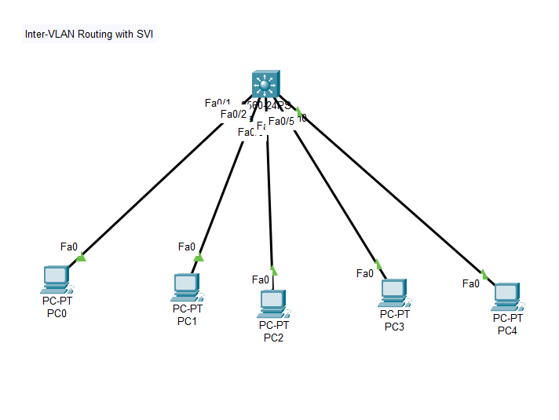
Open Switch 0(3560-24PS) – CLI prompt then type following commands
Switch>enable
Switch#config terminal
Switch (config)#vlan 10
Switch (config-vlan)# name Sales
Switch (config-vlan)# vlan 20
Switch (config-vlan)# name marketing
Switch (config-vlan)# vlan 30
Switch (config-vlan)# name HR
Switch (config-vlan)# vlan 40
Switch (config-vlan)# name Tech
Switch (config-vlan)# vlan 50
Switch (config-vlan)# name Non-Tech
Switch (config-vlan)# interface fastEthernet0/1
Switch (config-if)# switchport mode access
Switch (config-if)# switchport access vlan 10
Switch (config-if)# exit
Switch (config-vlan)# interface fastEthernet0/2
Switch (config-if)# switchport mode access
Switch (config-if)# switchport access vlan 20
Switch (config-if)# exit
Switch (config-vlan)# interface fastEthernet0/3
Switch (config-if)# switchport mode access
Switch (config-if)# switchport access vlan 30
Switch (config-if)# exit
Switch (config-vlan)# interface fastEthernet0/4
Switch (config-if)# switchport mode access
Switch (config-if)# switchport access vlan 40
Switch (config-if)# exit
Switch (config-vlan)# interface fastEthernet0/5
Switch (config-if)# switchport mode access
Switch (config-if)# switchport access vlan 50
Switch (config)# exit
Switch (config)# interface vlan 10
Switch (config-if)# ip address 10.0.0.1 255.0.0.0
Switch (config-if)# exit
Switch (config)# interface vlan 20
Switch (config-if)# ip address 20.0.0.1 255.0.0.0
Switch (config-if)# exit
Switch (config)# interface vlan 30
Switch (config-if)# ip address 30.0.0.1 255.0.0.0
Switch (config-if)# exit
Switch (config)# interface vlan 40
Switch (config-if)# ip address 40.0.0.1 255.0.0.0
Switch (config-if)# exit
Switch (config)# interface vlan 50
Switch (config-if)# ip address 50.0.0.1 255.0.0.0
Switch (config-if)# exit
Switch (config)# ip routing

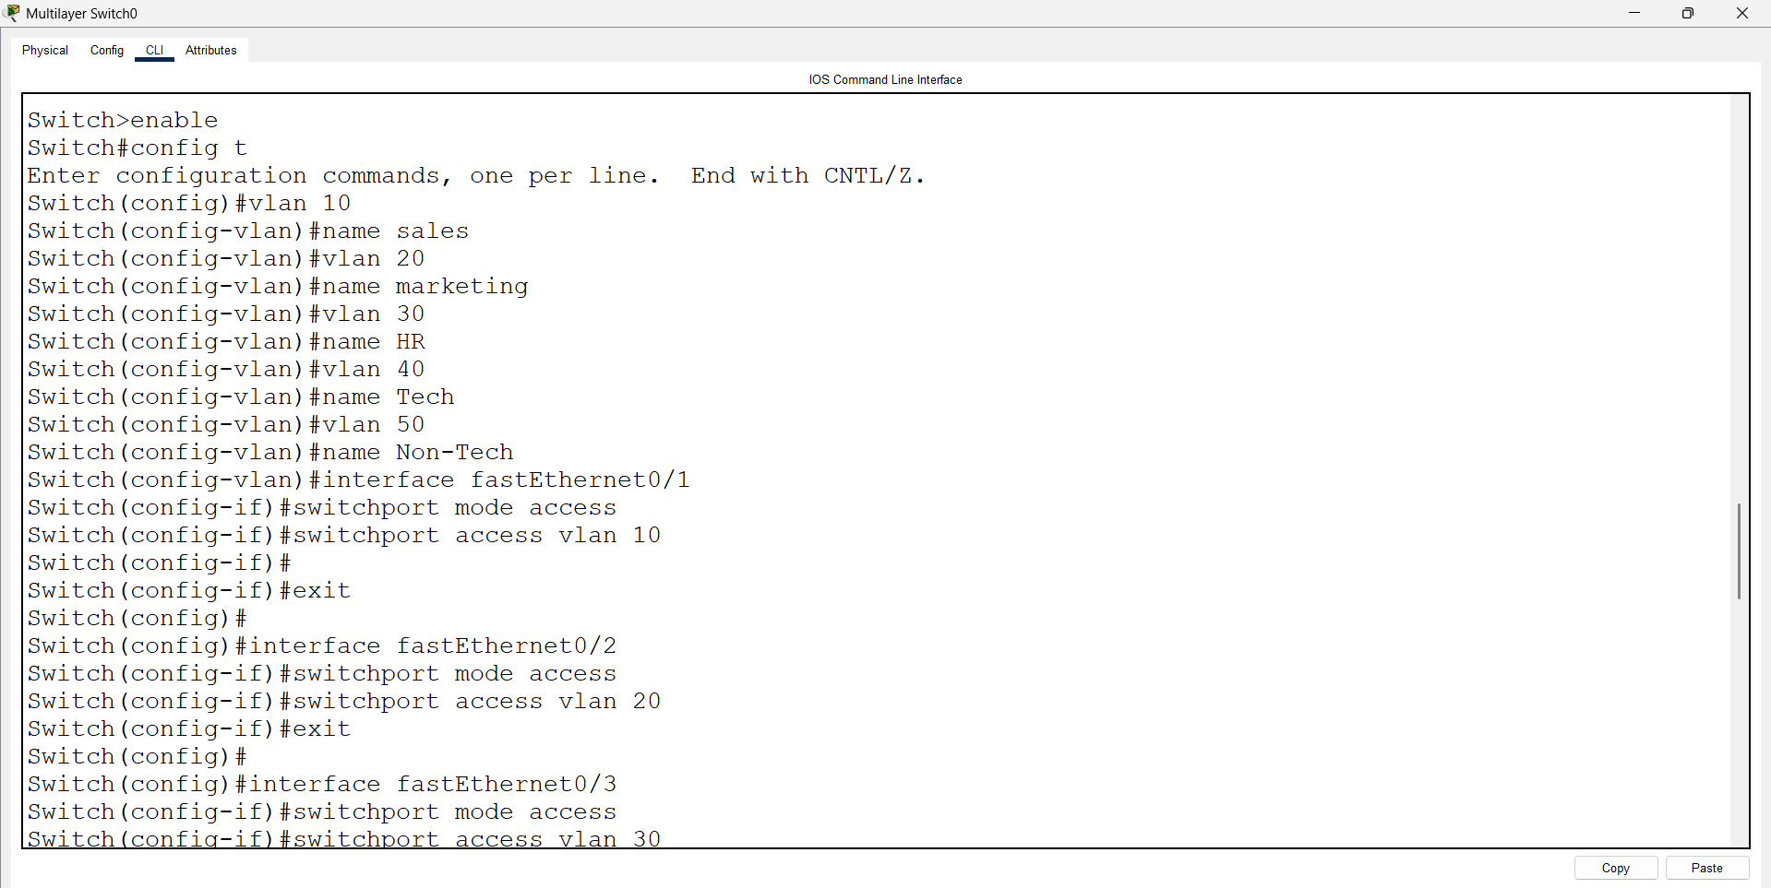

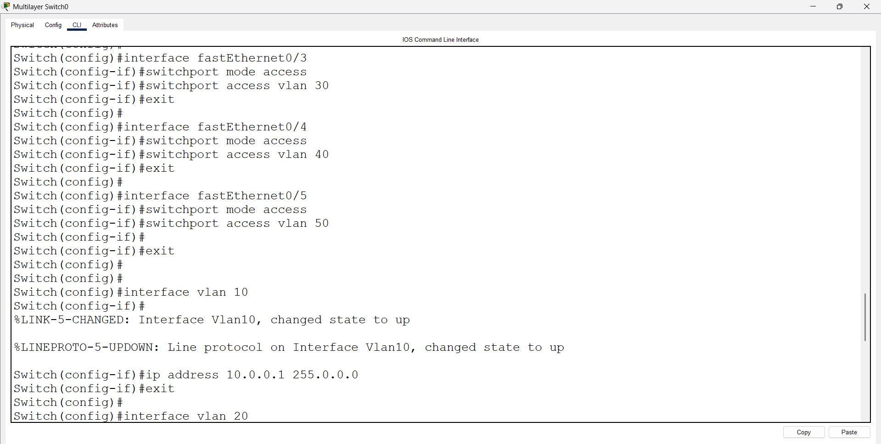

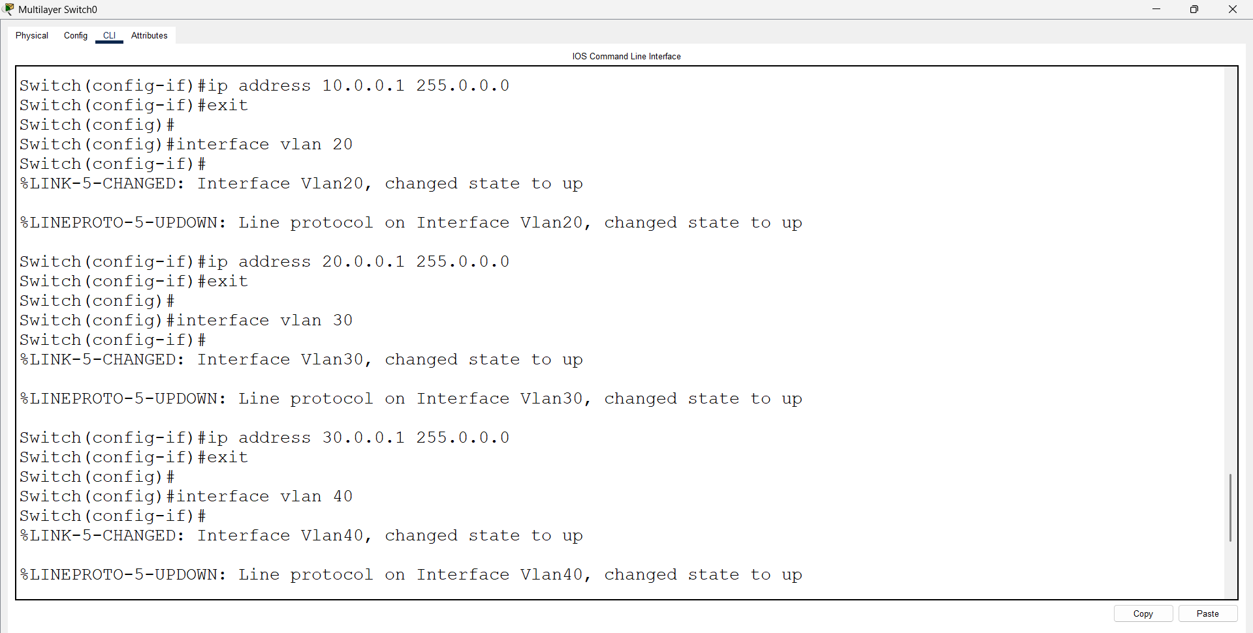
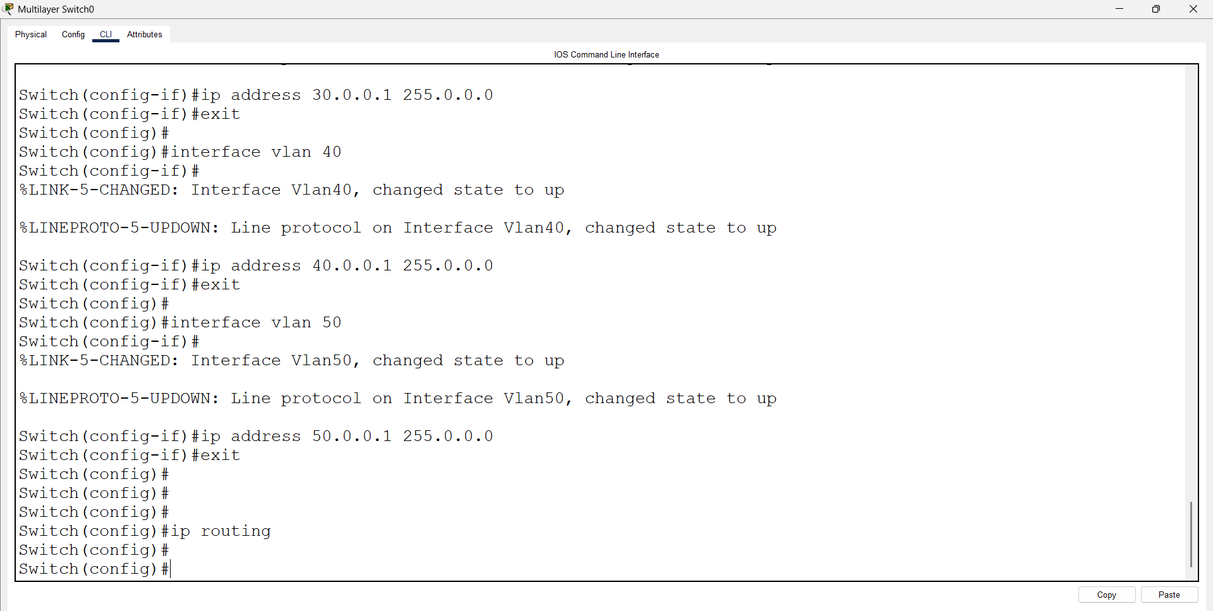
Switch(config)# ip routing
ip routing → This command enables routing on the Layer 3 switch so it can route between VLANs (Inter-VLAN routing).
